

SMALL OBERATING SYSTEM



kareem magdy albolaqi

sprint

10

Table of Contents

LAYERD ARCHTICTURE 2

CLASS DIGRAM 3

SEQUENCE DIGRAM 5

STATE MACHINE 6

# LAYERD ARCHTICTURE

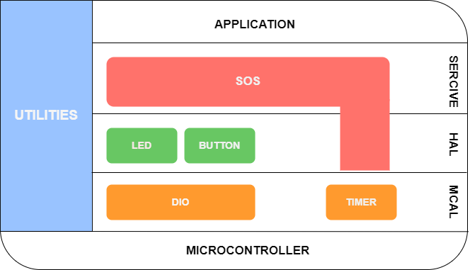

# CLASS DIGRAM

## 

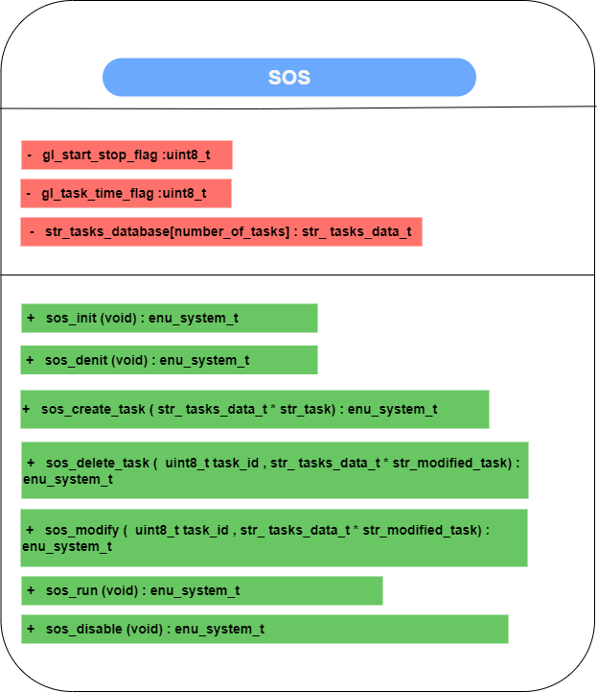

# SEQUENCE DIGRAM

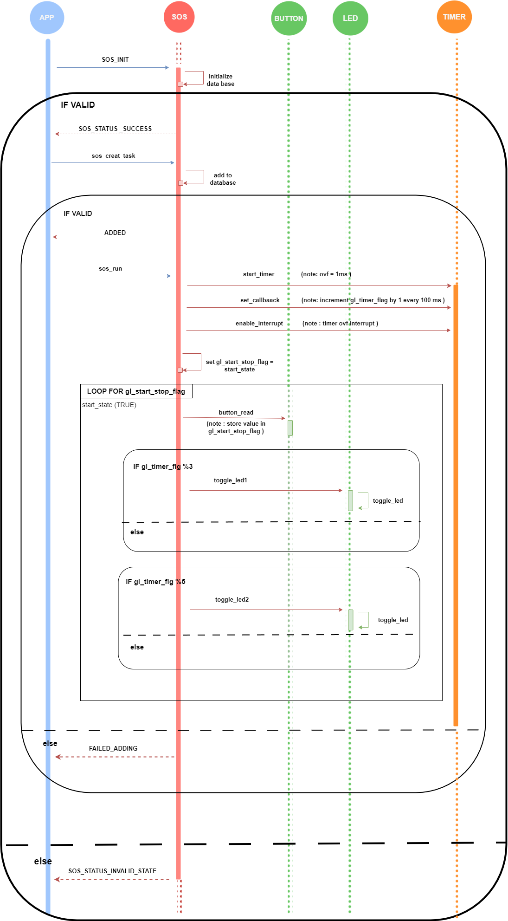



==0

==0

# STATE MACHINE